HSK 1 MODULE
Prepared by Nishtha V. Singh

Wk-1: INTRODUCTION & BASIC GREETINGS

[1]

Q. What is HSK?
A. HSK stands for Hanyu Shuiping Kaoshi, which translates to Chinese Proficiency Test. It's an internationally standardized exam that assesses the Chinese language proficiency of non-native speakers. The HSK is designed to evaluate skills in reading, writing, and listening comprehension.

- Purpose:
HSK tests the ability of non-native speakers to use Chinese in various contexts, including daily life, academic studies, and professional settings.
- Levels:
The test is structured into six levels, with increasing difficulty, ranging from basic (Level 1) to advanced (Level 6).
- Recognition:
The HSK is widely recognized and used by educational institutions and employers in China and internationally as a standard measure of Chinese language proficiency.
- Usage:
Passing HSK levels can be a requirement for university admissions in China, scholarship applications, and for demonstrating Chinese language skills in professional settings.

[2]

Q. What is Pinyin?
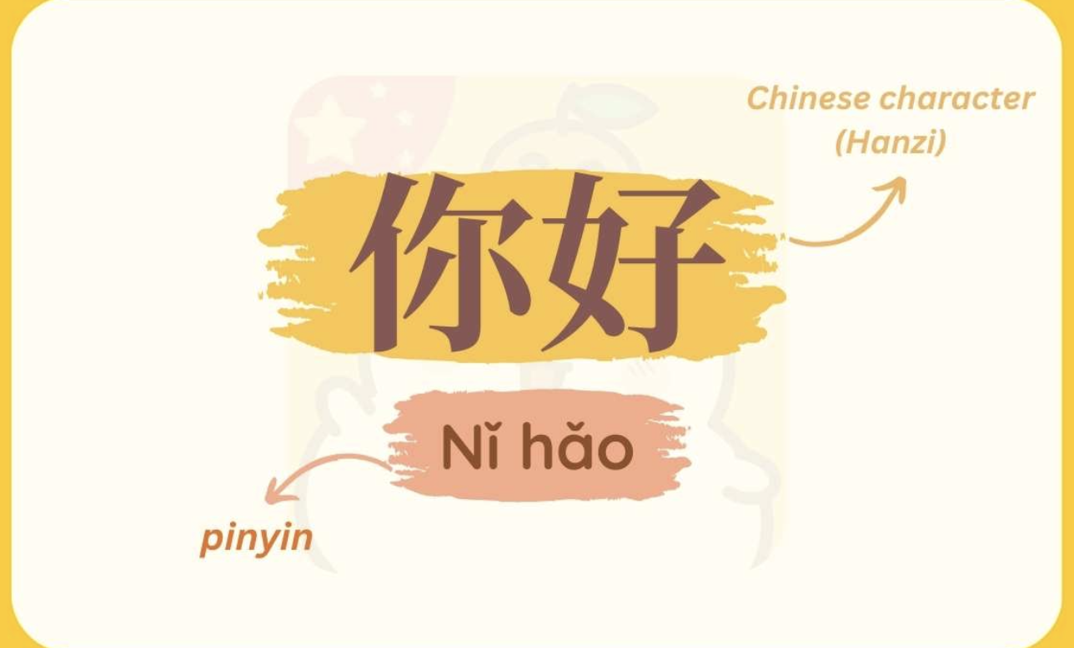
A. Pinyin is a system for romanizing Mandarin Chinese, using the Latin alphabet to represent the sounds of Chinese characters. It's essentially a phonetic alphabet for Mandarin, helping learners pronounce Chinese words accurately. Pinyin is widely used for teaching Mandarin, inputting Chinese on computers and phones, and transliterating Chinese names and places.

Q. What are Initials & Finals?
A. In Chinese Pinyin, syllables are composed of an initial, a final, and a tone. Initials are like the consonants at the beginning of a syllable, while finals are the vowel sounds (sometimes with a consonant ending) that follow the initial. Understanding initials and finals is crucial for correctly pronouncing Chinese syllables.

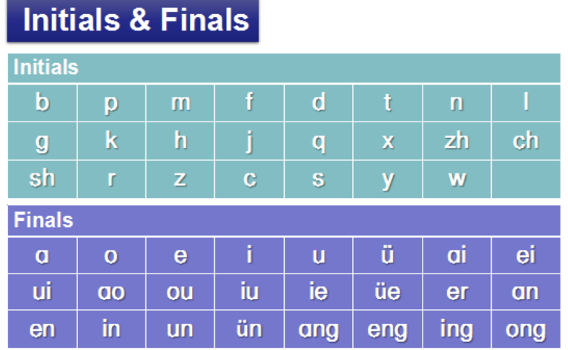

Q. What are Tones?
A. Tones are variations in pitch that distinguish the meaning of words. Mandarin Chinese uses five tones: four main tones and a neutral tone. These tones are crucial for proper pronunciation and understanding, as a different tone can completely change the meaning of a word.

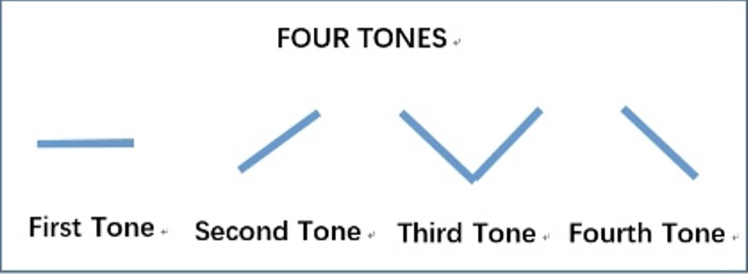

A

Here's a breakdown of the tones:
- First Tone: A high, level pitch.
- Second Tone: A rising pitch, like asking a question.
- Third Tone: A dipping tone, going low and then rising.
- Fourth Tone: A falling pitch, starting high and going low.
- Fifth Tone (Neutral): A light, unstressed tone with no specific pitch contour.

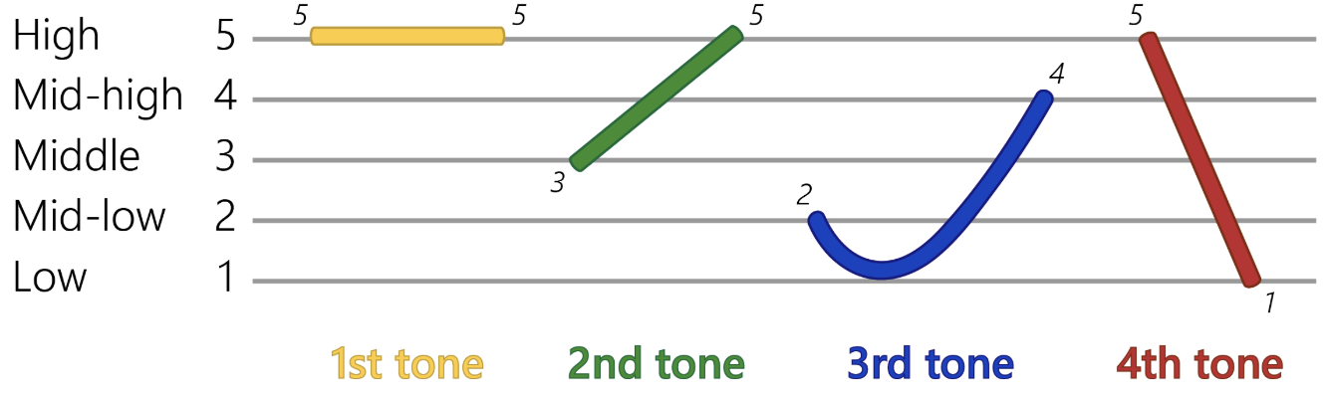

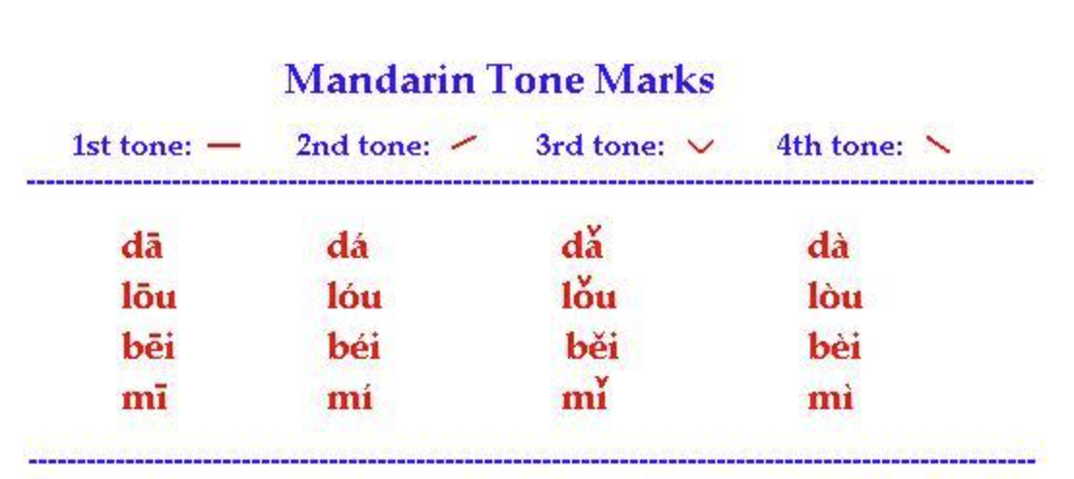

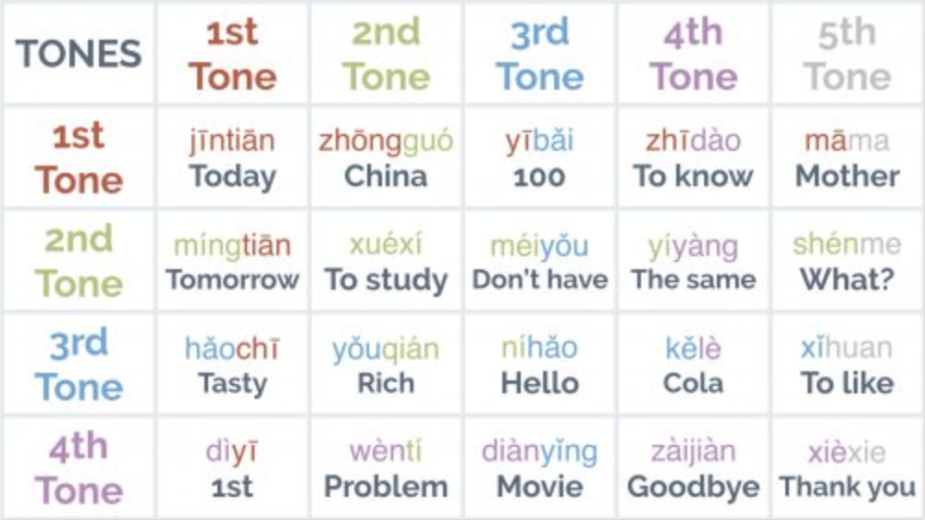

[3]

GREETINGS & SELF-INTRODUCTION

Vocabulary:-

Hello- 你好 (Nǐ hǎo)
Good morning- 早上好 (Zǎoshang hǎo)
Good afternoon- 下午好 (Xiàwǔ hǎo)
Good evening- 晚上好 (Wǎnshàng hǎo)
I- 我 (wǒ)
To call/to denote- 叫 (jiào)
Name- 名字 (míngzi)
Is/to be- 是 (shì) (shi+r)
Chinese- 中文 (Zhōngwén)
Student- 学生 (xuésheng)
Like- 喜欢 (xǐhuan)
No/negate- 不 (bù)
Busy- 忙 (máng)
You- 你 (Nǐ)

SUBJECT + VERB + OBJECT+ ma? (if asking)

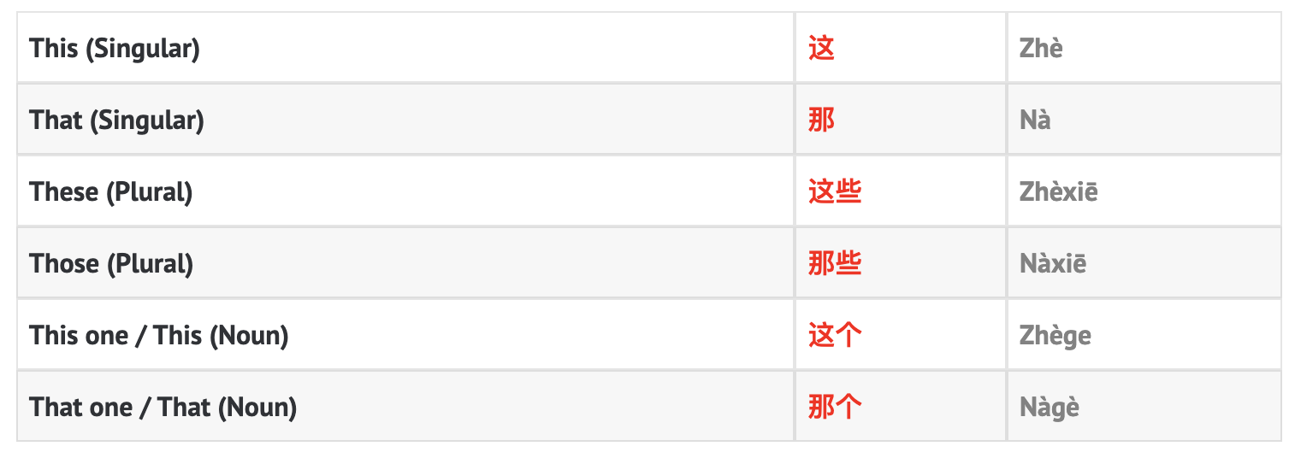

- 这里 (zhèlǐ): Here (demonstrative adverb)
- 那裡 (nàlǐ): There (demonstrative adverb)
- 哪里 (nǎlǐ): Where (interrogative adverb)
- 哪 (nǎ): Which

SELF-INTRODUCTION (BASIC)

- 你好，我 叫 哈利
Nǐ hǎo, wǒ jiào Hā lì
Hi, I'm Harry.

- 我是中文学生
Wǒ shì Zhōngwén xuésheng
I am a Chinese student.

- 很高兴认识你
Hěn gāoxìng rènshí nǐ
Nice to meet you/ Glad to see you.

[4]

NUMBERS (1-10)

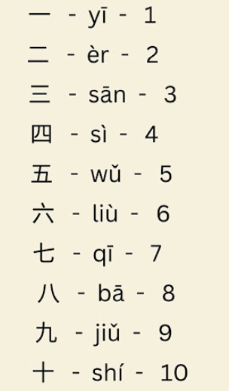

Numbers till 20:-

- Líng - Zero 零
- 11: 十一 (shí yī)
- 12: 十二 (shí èr)
- 13: 十三 (shí sān)
- 14: 十四 (shí sì)
- 15: 十五 (shí wǔ)
- 16: 十六 (shí liù)
- 17: 十七 (shí qī)
- 18: 十八 (shí bā)
- 19: 十九 (shí jiǔ)
- 20: 二十 (èr shí)

[5]

CHINESE GRAMMAR

Use of 吗- Question particle- ma?

In Mandarin Chinese, the particle 吗 (ma) is used to form yes-no questions. It's added to the end of a declarative sentence, transforming it into a question that typically requires a "yes" or "no" response.

Turning statements into questions:
By simply adding 吗 (ma) to the end of a sentence, you can change it from a statement to a question. For example:
- 你喜欢 (nǐ xǐhuan) - You like.
- 你喜欢吗? (nǐ xǐhuan ma) - Do you like?

Some examples of 吗

- 你很忙吗？(nǐ hěn máng ma?) - Are you very busy?
- 是，我很忙。(shì, wǒ hěn máng.) - Yes, I am very busy.
- 不是，我不忙。(bù shì, wǒ bù máng.) - No, I am not busy.

A: 你是学生吗？
Nǐ shì xuésheng ma?
Are you a student?
B: 是的。
Shì de.
Yes, I am.
A: 这是你的雨伞吗？
Zhè shì nǐ de yǔsǎn ma?
Is this your umbrella?
B: 不是。
Bú (4th tone) shì.
No, it’s not.
A: 你住在这里吗？
Nǐ zhù zài zhèli ma?
Do you live here?
B: 嗯。
Ǹg.
Mmm.

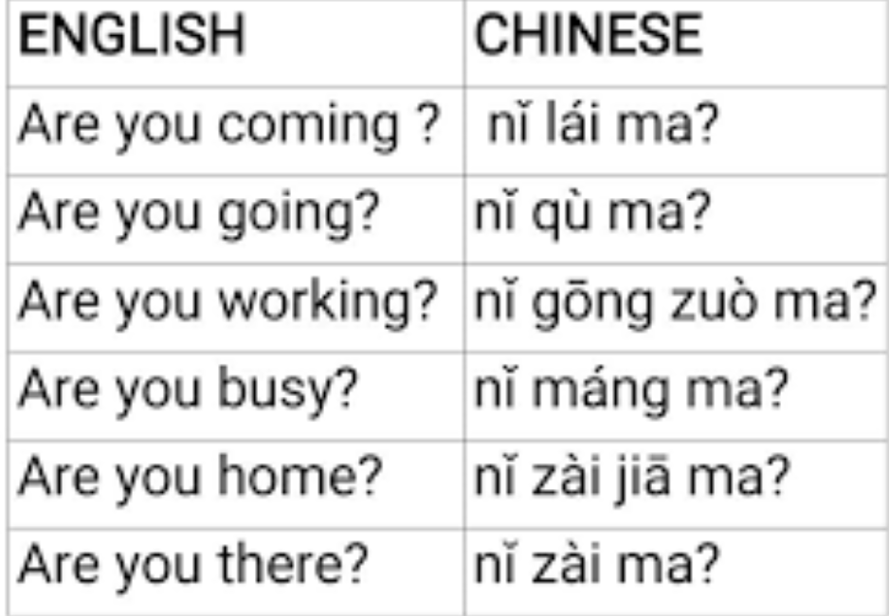

Use of 是 (shì)- Grammar particle
In Chinese, "是" (shì) primarily functions as the verb "to be," linking nouns together to explain what something or someone is. It's used similarly to the English "is," "am," or "are". It's also used in the phrase "是不是" (shì bú shì) to form questions, literally meaning "be not be.

- Example: "我是学生" (wǒ shì xuéshēng) - "I am a student".
- Example: "这是手机" (zhè shì shǒujī) - "This is a cell phone.

- 是不是 (shì bú shì) is used to ask yes/no questions, transforming a statement into a question.
- Example: "这是不是手机？" (zhè shì bú shì shǒujī?) - "Is this a cell phone?".
- Example: "苹果是不是水果？" (píngguǒ shì bú shì shuǐguǒ?) - "Are apples a kind of fruit?
- 是...的 (shì...de) can be used to emphasize a particular detail or aspect of a situation, similar to saying "It's that..." or "It was... that..." in English, according to resources on Chinese grammar.

Wk-2: FAMILY & NATIONALITY

[1]

Vocabulary:-

Family- 家 (Jiā)
Person- 人 (rén)
Country- 国家 (Guójiā)
Which- 哪个 (Nǎge)
Where- 哪儿 (nǎr)
They- 他们 (tāmen)

中国人 (zhōngguó rén) - Chinese
英国人 (yīngguó rén) - British
法国人 (fàguó rén) - French
印度人 (Yìn du rén)- Indian
爸爸 (bàba): Father
妈妈 (māma): Mother
哥哥 (gēge): Older brother
姐姐 (jiějie): Older sister
弟弟 (dìdi): Younger brother
妹妹 (mèimei): Younger sister
爷爷 (yéye) : Grand father
奶奶 (nǎinai) : Grand mother

- 你 是 哪 国人? (nǐ shì nǎ guó rén?): This is a question asking "What is your nationality?".
- 你是哪儿人? (nǐ shì nǎr rén?): This is a more informal way of asking "Where are you from?
- 我是 [nationality] 人 (wǒ shì [nationality] rén): This is the most common way to state your nationality. Replace "[nationality]" with the appropriate Chinese word for your country.
- For example, 我是美国人 (wǒ shì měiguó rén)" means "I am American.

[2]

Use of 是 (shì)- Grammar particle

In Chinese, "de" (的) is a grammatical particle with distinct uses. "的" (de) is used to indicate possession before a noun.

Here's a breakdown:
的 (de): Possessive/Modifying Particle
- Indicates possession or belonging: "我的书" (wǒ de shū) - "my book".
- Indicates modification or description: "漂亮的衣服" (piàoliang de yīfu) - "beautiful clothes".
- Connects adjectives or other words to a noun: "大大的房子" (dà dà de fángzi) - "big house.
Example:
- 我的书 (wǒ de shū) - my book.
- 你的朋友 (nǐ de péngyou) - your friend.
- 他们的家 (tāmen de jiā) - their home.
- 这是我的 (zhè shì wǒ de) - This is mine

Use of 也 (yě)-

In Chinese, the word "also" or "too" is commonly translated as 也 (yě). It's used to indicate similarity or agreement, and it generally precedes the verb or adjective in a sentence.

How to use 也 (yě):
- Placement: "也" (yě) is usually placed before the verb in a sentence.
- Example:
  - 我喜欢苹果，你也喜欢吗？ (Wǒ xǐhuan píngguǒ, nǐ yě xǐhuan ma?) - I like apples, do you like them too?
  - 我也是学生。(Wǒ yě shì xuéshēng.) - I am also a student.
  - 他也很高兴。(Tā yě hěn gāoxìng.) - He is also very happy

- Some more examples-

我 也 喜欢。Wǒ yě xǐhuan.
I also like it.
我 也 是 学生 。Wǒ yě shì xuésheng.
I am a student too.
她 也 有 一个 儿子。Tā yě yǒu yī gè érzi.
She also has a son.
他们 也 是 法国 人 吗？Tāmen yě shì Fǎguó rén ma?
Are they also French?
我 也 想 学 中文。Wǒ yě xiǎng xué Zhōngwén.
I also want to study Chinese.
他们 也 会 去吗？Tāmen yě huì qù ma?
Are they also going?
我 妈妈 也 喜欢 吃 饺子。Wǒ māma yě xǐhuan chī jiǎozi.
My mother likes to eat boiled dumplings too.
孩子 也 可以 喝酒 吗？Háizi yě kěyǐ hējiǔ ma?
Can kids drink alcohol too?
你 也 想 来 我 家 吗？Nǐ yě xiǎng lái wǒ jiā ma?
Do you want to come to my house too?
她 也 觉得 这 个 老师 不 好。Tā yě juéde zhège lǎoshī bù hǎo.
She also thinks this teacher isn't good.
[3]

Measure words & Sentences

Q: What is a Measure Word?
A: In Chinese, measure words (also known as classifiers) are words placed between a number and a noun to specify the quantity or unit. They are crucial for proper grammar and indicate the type, shape, or other characteristics of the noun.

For example:
In Chinese, the measure word "口 (kǒu)" primarily functions to count family members. It literally means "mouth" but is used idiomatically to refer to individuals within a household. For instance, "一家三口 (yī jiā sān kǒu)" translates to "a family of three.

你家有几口人？ (nǐ jiā yǒu jǐ kǒu rén?) - How many people are in your family?
我家有五口人 (wǒ jiā yǒu wǔ kǒu rén)" means "My family has five people.

[4]

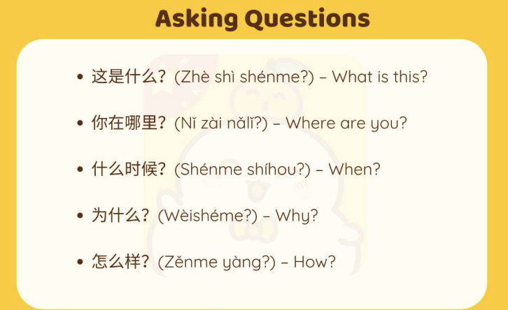

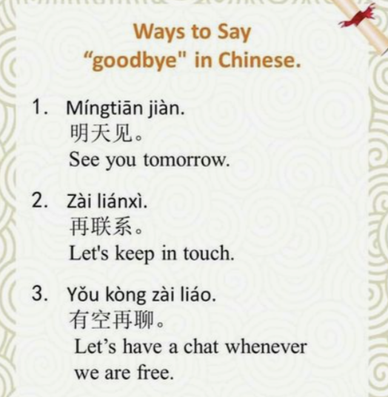

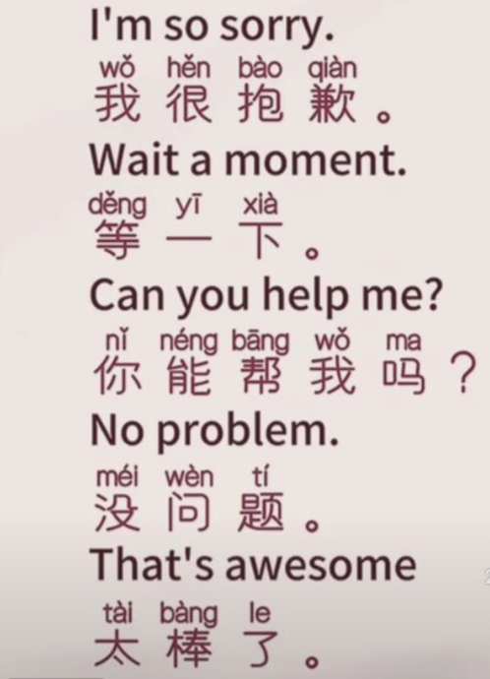
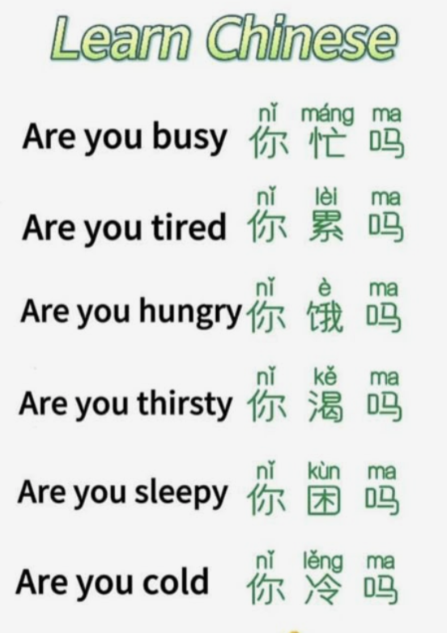

Wk-3: TIME & DATES

[1]

Vocabulary with sentences:-

TIME

1. Time Periods:
- Morning (early): 早上 (zǎoshang) - roughly 12 am to 8 am.
- Late Morning: 上午 (shàngwǔ) - 9 am to 11 am.
- Noon: 中午 (zhōngwǔ) - 12 pm to 1 pm.
- Afternoon: 下午 (xiàwǔ) - 2 pm to 6 pm.
- Evening/Night: 晚上 (wǎnshàng) - 7 pm to 11 pm, or any time after dark.
2. Telling the Hour:
- Use the number corresponding to the hour, followed by diǎn (点), meaning "o'clock".
- Examples:
  - 1 o'clock: 一点 (yī diǎn)
  - 2 o'clock: 两点 (liǎng diǎn) (note: "two" is liǎng, not èr, when telling time).
  - 3 o'clock: 三点 (sān diǎn)
  - 12 o'clock: 十二点 (shí èr diǎn)
3. Telling the Minutes:
- Follow the hour with the number of minutes, and then use the word fēn (分) (meaning "minute").
- Examples:
  - 10 minutes: 十分 (shí fēn)
  - 45 minutes: 四十五分 (sì shí wǔ fēn)
  - In most cases, "fēn" is optional, and you can just say the numbers.

In Chinese, the word for "second" is 秒 (miǎo). It's pronounced "miao" and can also be written as 秒钟 (miǎo zhōng), but often just "秒" is used when speaking about time. For example, 60秒 (liù shí miǎo) means 60 seconds.

4. Examples:
- 9:10 AM: 早上九点十分 (zǎoshang jiǔ diǎn shí fēn)
- 3:20 PM: 下午三点二十 (xià wǔ sān diǎn èr shí)
- 8:00 PM: 晚上八点 (wǎnshàng bā diǎn)
- 12:15 PM (noon): 中午十二点一刻 (zhōng wǔ shí èr diǎn yí kè)

In Chinese, "yi ke" (一刻) translates to "a quarter" or "15 minutes". It specifically refers to a quarter of an hour. So, "yi ke" (一刻) is used to express 15 minutes past the hour. For example, "sāndiǎn yīkè" (三点一刻) means "three fifteen" or "a quarter past three”.

5. Other useful terms:
- Half past: diǎn bàn (点半) (number + diǎn + bàn).
- Quarter past: diǎn yī kè (点一刻) (number + diǎn + yī kè).
- Minutes to: chà (差)
- Now: 现在 (xiàn zài)

DATES
6. To express dates in Chinese, you say the year, then the month, then the day, using the format "year 年 month 月 day 日/号".
Key Vocabulary:
- 年 (nián): year
- 月 (yuè): month
- 日 (rì) or 号 (hào): day. 日 is more formal, 号 is more common in spoken Chinese.
- 今天是 (jīntiān shì): Today is
- 星期 (xīngqī) week
- 几 (jǐ) how many, several (“kitna” in Hindi)

Example:
- Today is August 21, 2025: 今天是2025年8月21日 (jīntiān shì èr líng èr wǔ nián bā yuè èr shí yī rì)
More Examples:
- February 14, 2019: 2019年2月14日 (èr líng yī jiǔ nián èr yuè shí sì rì) or 2019年2月14号
- June 10, 2024: 2024年6月10日 (èr líng èr sì nián liù yuè shí rì)
To ask about the date:
- What date is it today? 今天几月几日？(jīntiān jǐ yuè jǐ rì?) or 今天几月几号？(jīntiān jǐ yuè jǐ hào?)
- What day of the week is it? 今天星期几？(jīntiān xīngqī jǐ?)

[2]

几 (jǐ) Sentences

- 他 有 几 个 孩子？Tā yǒu jǐ gè háizi?
How many kids does he have?
- 你 家 有 几 个 房间？Nǐ jiā yǒu jǐ gè fángjiān?
How many rooms are there in your house?
- 他们 在 这里 住 几 个 星期？Tāmen zài zhèlǐ zhù jǐ gè xīngqī?
How many weeks are they staying here?
- 你 带 了 几 件 衣服？Nǐ dài le jǐ jiàn yīfu?
How many pieces of clothing have you brought?
- 老板 每 天 工作 几 个 小时 ？Lǎobǎn měi tiān gōngzuò jǐ gè xiǎoshí?
How many hours does the boss work every day?

PRACTICE:-
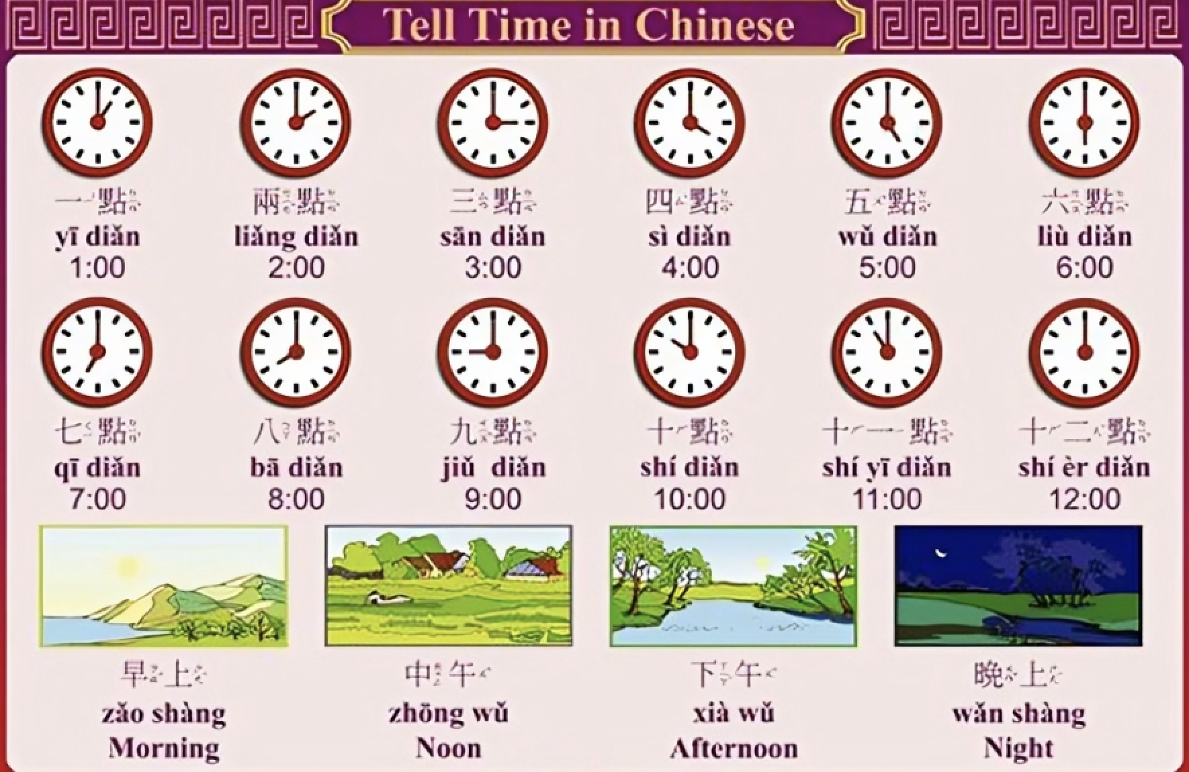

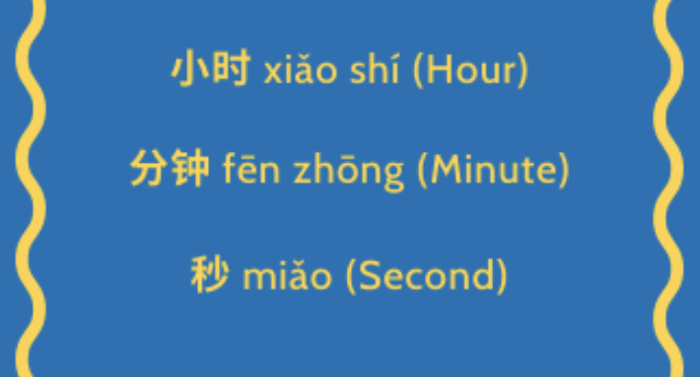
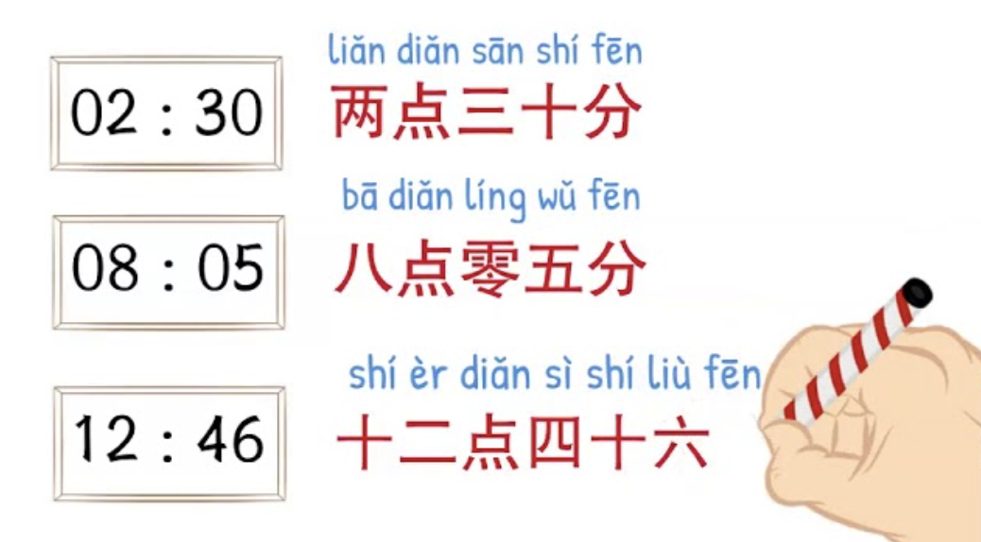

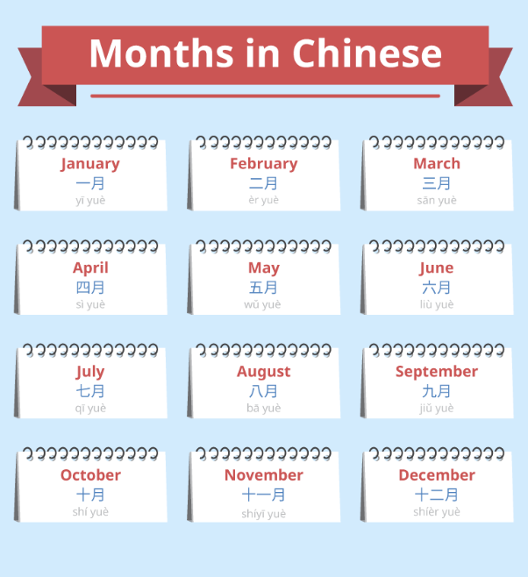

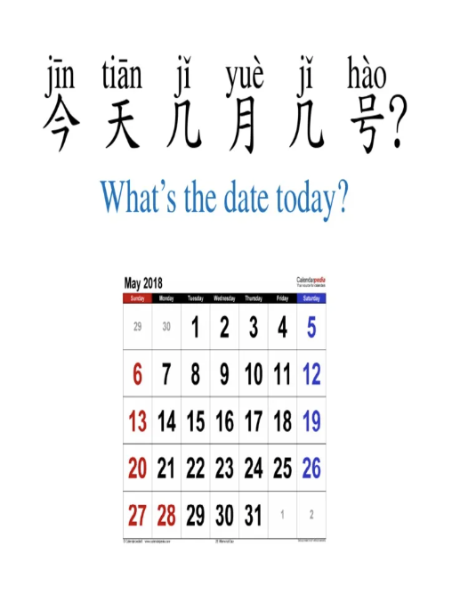

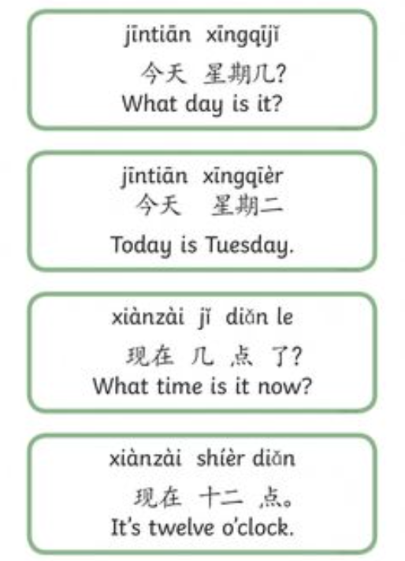

Wk-4: DAILY ACTIVITIES IN CHINESE

Basic Sentences
- 我吃早饭: (Wǒ chī zǎofàn) - I eat breakfast.
- 你吃了吗？: (Nǐ chī le ma?) - Did you eat?
- 他想吃面: (Tā xiǎng chī miàn) - He wants to eat noodles.
- 我们一起吃饭吧: (Wǒmen yīqǐ chīfàn ba) - Let's eat together.

In Chinese, "enjoy your meal" is said as "慢慢吃" (màn màn chī). This phrase literally translates to "eat slowly," which is a common way to wish someone an enjoyable meal. Another phrase you might hear is "祝你好胃口" (zhù nǐ hǎo wèikǒu), which means "wish you a good appetite."

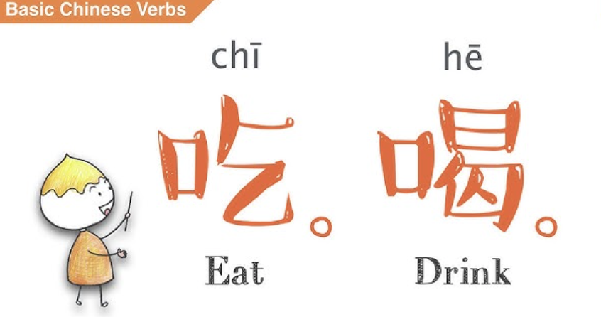

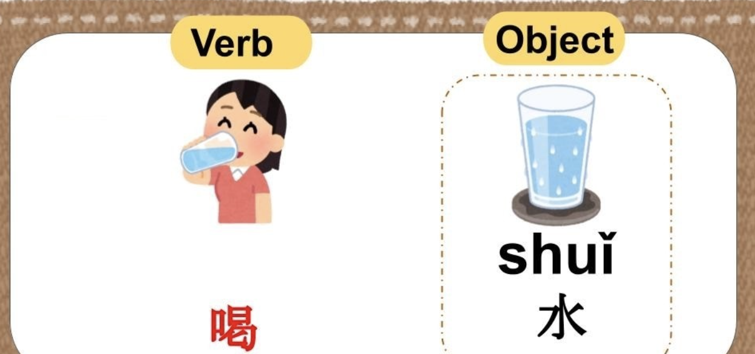

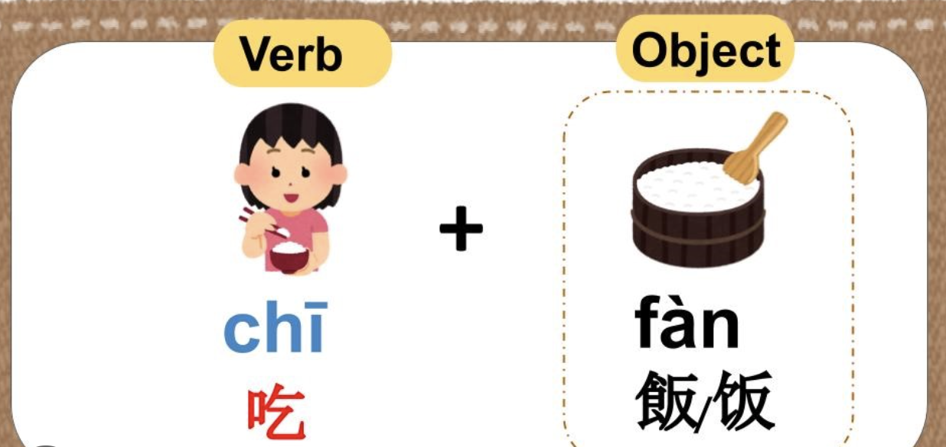

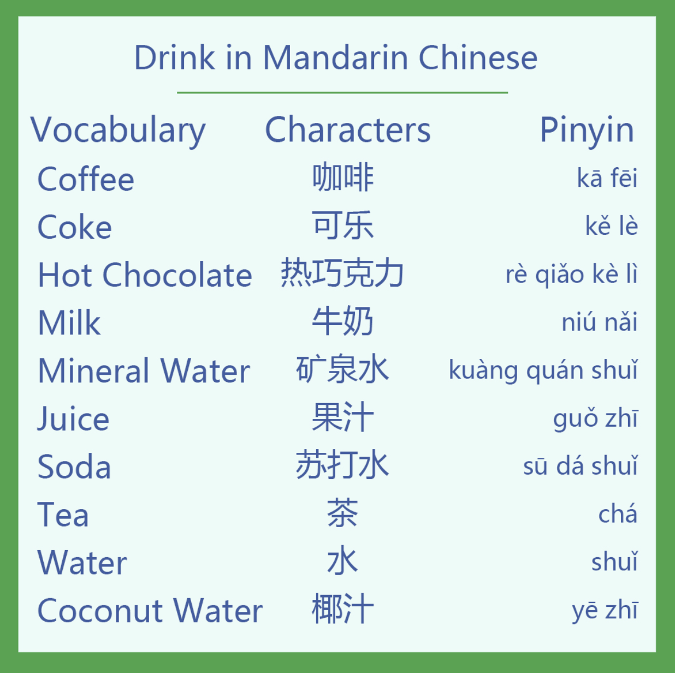

来 (lái) and 去 (qù) are both words that help to express direction from the perspective of the speaker. 来 (lái) means "come" (towards the speaker), while 去 (qù) means "go" (away from the speaker). For example, if you are in China, a local person might ask you: "When did you come to China?" using 来 (lái). Another example is if you want to go from China to Japan, your friends might ask you: “When are you going to Japan?" using 去 (qù).

- 妈妈 要 去 超市。Māma yào qù chāoshì.
Mom will go to the supermarket.
- 老板 今天 来 公司 吗？Lǎobǎn jīntiān lái gōngsī ma?
Is the boss coming into the office today?
- 你 现在 来南京 路 吧。Nǐ xiànzài lái Nánjīng Lù ba.
Come to Nanjing Road now.
- 你 不 想 来 我们 公司 工作 吗？Nǐ bù xiǎng lái wǒmen gōngsī gōngzuò ma?
Do you not want to come to work for our company?
- 去年 她 去 美国 工作 了 几 个 月 。Qùnián tā qù Měiguó gōngzuò le jǐ gè yuè.
Last year she went to work in the USA for a few months.
- 你们 想 去 Starbucks 还是 Costa？Nǐmen xiǎng qù Starbucks háishì Costa?
Would you like to go to Starbucks or Costa?
- 周末 我 喜欢 去 朋友 家。Zhōumò wǒ xǐhuan qù péngyou jiā.
I like to go to my friends' places on the weekends.
- 我 今天 不 上班，你们 可以 来 我 家 吃饭 。Wǒ jīntiān bù shàngbān, nǐmen kěyǐ lái wǒ jiā chīfàn.

The character "zuo" has several different meanings in Chinese, including the verbs 做 (zuò) for "to do, make" or "to cook," and 坐 (zuò) for "to sit" or "to ride". Other common characters pronounced "zuo", 作 (zuò), often used in more formal contexts for "to do, make," like making a report or a presentation.

Examples using 做 (zuò - to do, make, cook)
- 你今天做什么？: (Nǐ jīntiān zuò shénme?) - What are you doing today?
- 我爱做中国饭。: (Wǒ ài zuò zhōngguó fàn.) - I love to cook Chinese food.
- 做计划: (zuò jìhuà) - to make plans
Examples using 坐 (zuò - to sit, to ride)
- 坐下: (zuò xià) - to sit down
- 坐车: (zuò chē) - to take the car, bus, or train
- 坐地铁: (zuò dìtiě) - to ride the subway
Examples using 作 (zuò - to do, make)
- 作报告: (zuò bàogào) - to make a report
- 作比较: (zuò bǐjiào) - to make comparisons
- 作回应: (zuò huíyìng) - to respond

Wk-5: SHOPPING, NUMBERS & DIRECTIONS

Vocabulary with sentences:-

Greetings & General Phrases
- 你好 (Nǐ hǎo) - Hello
- 谢谢 (Xièxie) - Thank you
- 多少钱? (Duōshǎo qián?) - How much is it?
- 太贵了 (Tài guì le) - It's too expensive
- 可以便宜一点吗? (Kěyǐ piányi yīdiǎn ma?) - Can it be a little cheaper?
Expressing Interest & Purchasing
- 我要买这个 (Wǒ yào mǎi zhège) - I want to buy this
- 就要这个 (Jiù yào zhège) - I'll take this one
- 我要一个 [item] (Wǒ yào yī ge [item]) - I want one [item] (e.g., 一支笔 (yī zhī bǐ) for a pen)
- 我能试试吗? (Wǒ néng shì shì ma?) - Can I try it on?
Payment & Logistics
- 我能刷卡吗? (Wǒ néng shuākǎ ma?) - Can I pay by card?
- 能用现金吗? (Néng yòng xiànjīn ma?) - Can I use cash?
- 找零 (Zhǎolíng) - Change (money)
Asking for Help
- 请问 (Qǐngwèn) - Excuse me, may I ask...
- 售货员 (Shòuhuòyuán) - Salesperson
- 有没有 [item]? (Yǒu méiyǒu [item]?) - Do you have [item]?

Key Vocabulary
- 买东西 (Mǎi dōngxi) - To buy things
- 商场 (Shāngchǎng) - Shopping mall
- 超市 (Chāoshì) - Supermarket
- 收据 (Shōujù) - Receipt
- 退货 (Tuìhuò) - To return goods/refund

- MEASURE WORDS

In Chinese, measure words (also known as classifiers) are words placed between a number and a noun to specify the quantity or unit. They are crucial for proper grammar and indicate the type, shape, or other characteristics of the noun.

Function:
Measure words quantify nouns, similar to "a piece of" or "a cup of" in English.

Common Measure Words and Examples:
- 个 (gè):
The most versatile measure word, used when no other specific measure word is known or for general use.
Example: 一个人 (yī gè rén) - one person

- 只 (zhī):
Used for certain animals and items that come in pairs.
Example: 一只猫 (yī zhī māo) - one cat

- 本 (běn):
Used for books and other bound items.
Example: 一本书 (yī běn shū) - one book

- 条 (tiáo):
Used for long, thin objects like rivers, pants, or snakes.
Example: 一条鱼 (yī tiáo yú) - one fish

- 张 (zhāng):
Used for flat, thin objects like paper, tickets, or tables.
Example: 一张纸 (yī zhāng zhǐ) - one piece of paper

- 杯 (bēi):
Used for cups and glasses.
Example: 一杯水 (yī bēi shuǐ) - one cup of water

- 辆 (liàng):
Used for vehicles.
Example: 一辆车 (yī liàng chē) - one car

- 双 (shuāng):
Used for pairs.
Example: 一双鞋 (yī shuāng xié) - one pair of shoes

- 瓶 (píng):
Used for bottles.
Example: 一瓶水 (yī píng shuǐ) - one bottle of water
- 把 (bǎ):
Used for objects held in the hand or for a handful.
Example: 一把刀 (yī bǎ dāo) - one knife, a handful of something

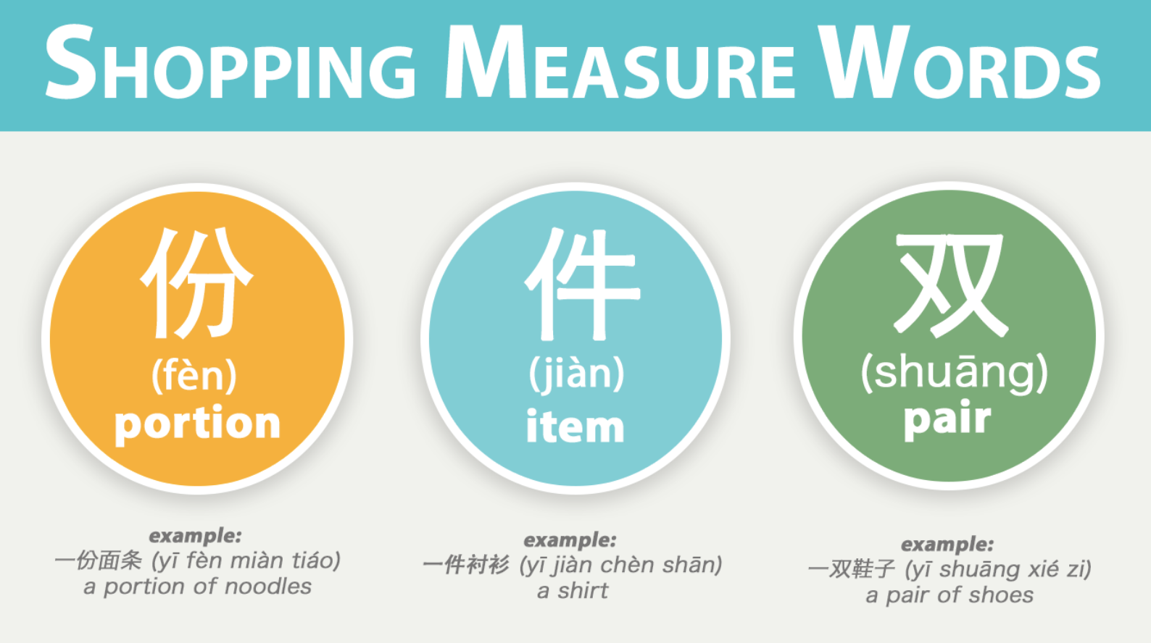

NUMBERS- THOUSANDS & TEN THOUSANDS

In Mandarin Chinese, "thousand" is 千 (qiān) and "ten thousand" is 万 (wàn). Numbers are built by combining these units with the smaller digits. For example, 3,456 is 三千四百五十六 (sān qiān sì bǎi wǔ shí liù), and 12,000 is 一万二千 (yī wàn èr qiān).

Numbers up to 9,999
Numbers are read in order from left to right, similar to English.
- 一百: (yī bǎi): One hundred
- 一千: (yī qiān): One thousand
- 三千八百八十七: (sān bǎi bā shí qī): 387
- 四千八百九十三: (sì qiān bā bǎi jiǔ shí sān): 4,893
- 九千九百九十九: (jiǔ qiān jiǔ bǎi jiǔ shí jiǔ): 9,999
Numbers 10,000 and above
- 万: (wàn) is the unit for ten thousand.
- To express numbers above ten thousand, you use the same pattern, with the unit 万 (wàn) followed by any smaller numbers.
- 一万: (yī wàn): Ten thousand
- 一万四千: (yī wàn sì qiān): Fourteen thousand
- 一万二千: (yī wàn èr qiān): Twelve thousand
- 五万零三百: (wǔ wàn líng sān bǎi): Fifty thousand three hundred
- 十万: (shí wàn): Hundred thousand

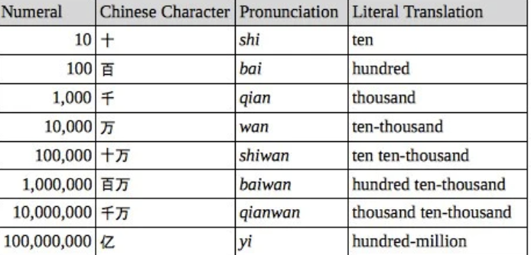

- CURRENCY

Yuan
The yuán (元) is the basic unit of the renminbi. It’s the Chinese equivalent of a dollar or a pound.
Things for sale in China, from toothpaste to luxury cars, are expressed in yuán.
Colloquially however, people usually say ‘kuài’ (块) instead of yuán. This is like saying a ‘buck’ in the US or a ‘quid’ in the UK.

One yuán is made up of 10 jiǎo (角) or, in spoken Chinese, 10 máo (毛).
And, one jiǎo is made up of 10 分 (fēn). This is like a penny (i.e. basically worthless!).

How to count Chinese money
For whole numbers, simply follow this structure:
Number + 块 (kuài)
Remember, 块 (kuài) is the common way of saying 元 (yuán).
So, RMB 3 is 三块 (sān kuài).
Easy!

If it’s not a whole number
Just follow this structure:
Number + 块 + Number + 毛 (máo)
Remember, there are 10 毛 (máo) in a 块 (kuài).
So, RMB 3.5 is 三块五毛 (sān kuài wǔ máo).
When you’re buying things in the shops, however, people generally don’t say the last word (毛). It’s implied, so it drops off.
In English, it’s like saying “three dollars fifty” rather than “three dollars fifty cents”.
So, RMB 3.5 is 三块五 (sān kuài wǔ) – the colloquial way.

How do you write ‘money’ in Chinese?
It’s 钱 (qián).
When you’re counting Chinese money, adding 钱 (qián) to the end of the sentence is optional.
So, for a bowl of rice costing RMB 3, you could say:
三块钱 (sān kuài qián) or just 三块 (sān kuài).
n Chinese supermarkets, prices will be more specific. For example, an item might cost RMB 3.56.
This would be said as 三块五毛六 (sān kuài wǔmáo liù).
So, just add 6 on the end.
The full sentence is really 三块五毛六分 (sān kuài wǔmáo liù fēn), but the 分 (fēn) is often dropped off.
In Chinese supermarkets, prices will be more specific. For example, an item might cost RMB 3.56.
This would be said as 三块五毛六 (sān kuài wǔmáo liù).
So, just add 6 on the end.
The full sentence is really 三块五毛六分 (sān kuài wǔmáo liù fēn), but the 分 (fēn) is often dropped off.

So, when you’re out shopping it’s important to think and act like a Chinese person.
They would never accept the first price they’re given!
A simple conversation might go like this:
You: 多少钱? (Duōshǎo qián?) How much is it?
Vendor: 一百块钱 (Yībǎi kuài qián) 100 yuan.
You: 太贵了。六十块可以吗？ (Tài guile. Liùshí kuài kěyǐ ma?) It’s too expensive. How about 60 yuan?
Vendor: 六十块太低了。八十块, 好吗？(Liùshí kuài tài dī le. Bāshí kuài, hǎo ma?) 60 yuan is too low. Is 80 yuan OK for you?
You: 好的 (Hǎo de). OK.

To explain directions in Chinese, you should learn the cardinal directions: 东 (dōng) for east, 南 (nán) for south, 西 (xī) for west, and 北 (běi) for north. Remember that these are said in a different order than in English, and you can add words like 边 (biān), 方 (fāng), or 面 (miàn) to specify sides or directions. For example, to give directions to a place, you can say it is on the "north side" (北方, běifāng) of a city.

Cardinal Directions
The four basic cardinal directions in Chinese are:
- 东 (dōng) - East
- 南 (nán) - South
- 西 (xī) - West
- 北 (běi) - North
Intercardinal Directions
You can combine these to form intercardinal directions:
- 东南 (dōngnán) - Southeast
- 东北 (dōngběi) - Northeast
- 西南 (xīnán) - Southwest
- 西北 (xīběi) - Northwest
Adding "Side" or "Direction"
In everyday use, you can add a word after the cardinal direction to indicate a side or part:
- 边 (biān): Means "edge" or "side". For example, 南边 (nánbiān) means "south side".
- 方 (fāng): Means "direction" or "part". For example, 北方 (běifāng) means "north part" or "the north".
- 面 (miàn): Also means "side". For example, 东面 (dōngmiàn) means "east side".
Example
To say "Beijing is in the north part of China," you would say: 北京在中国的北方 (Běijīng zài Zhōngguó de běifāng)

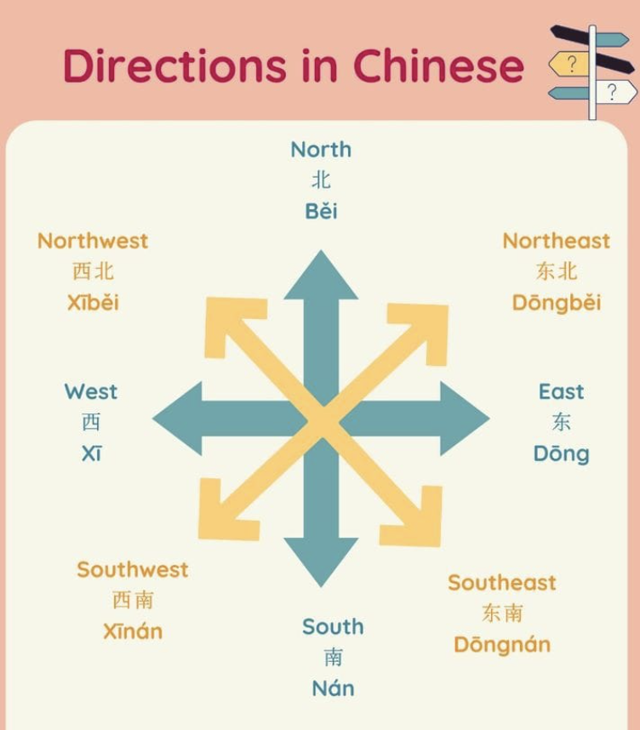

Wk-6: REVISION

- Family
- Time & Dates
- Daily Activities
- Self-Intro in Chinese

Wk-7: REVISION

- Shopping
- Location
- Pricing
- Directions

Wk-8: MOCK-TEST

- Reading & Listening
- QnA Session
- Live exam with markings

~ END OF THE MODULE ~
Prepared by Nishtha V. Singh

